FL-01: Workflow Audit

- Workflow Audit:
# | Recurring Task | Classification | One-line Rationale
1 | Research APIs and third-party integrations for internship/client projects | Collaborate with AI | AI accelerates research and explains concepts, but I verify everything using official documentation.
2 | Read and understand technical documentation (APIs, frameworks, SDKs) | Delegate to AI with Review | AI summarizes lengthy documentation, but I review the original before implementation.
3 | Debug ASP.NET Core, Entity Framework Core, and SQL Server issues | Collaborate with AI | AI suggests possible fixes, while I identify the root cause and validate the solution through testing.
4 | Develop backend APIs and business logic for semester and personal projects | Collaborate with AI | AI helps with implementation ideas and boilerplate code, but I make architecture and coding decisions.
5 | Build frontend components in React and integrate them with APIs | Collaborate with AI | AI assists with component structure and debugging, while I ensure the UI meets project requirements.
6 | Write SQL queries, LINQ queries, and optimize database operations | Delegate to AI with Review | AI generates query drafts quickly, but I verify correctness and performance before use.
7 | Train, evaluate, and improve machine learning models for academic projects | Collaborate with AI | AI helps analyze results and suggests improvements, but I interpret metrics and choose the final model.
8 | Prepare technical documentation, README files, and project reports | Delegate to AI with Review | AI creates a structured first draft, and I review it for technical accuracy and completeness.
9 | Prepare for interviews by studying .NET, SQL, APIs, and Machine Learning concepts | Delegate to AI with Review | AI explains concepts and generates practice questions, but I verify my understanding independently.
10 | Write professional emails, internship applications, and LinkedIn messages | Delegate to AI with Review | AI improves clarity and professionalism, while I personalize every message before sending.
11 | Plan weekly internship goals, coursework, and project milestones | Collaborate with AI | AI helps prioritize tasks, but I make the final decisions based on deadlines and workload.
12 | Attend meetings, gather requirements, and communicate with supervisors | Just Me | Understanding requirements, asking questions, and building trust require my direct participation.
13 | Decide project architecture, technology choices, and implementation strategy | Just Me | These decisions involve technical judgment, trade-offs, and accountability that I must own.
14 | Generate repetitive boilerplate code (DTOs, models, CRUD scaffolding, documentation templates) | Fully Automate | These repetitive tasks follow predictable patterns and only require a final quality review.

- Claude Project Custom Instructions:
Project Name
ML Internship - FlyRank
Custom Instructions
About Me:
I am Azan Shah, a Software Engineering student at FAST-NUCES and an ML Intern at FlyRank. I primarily work with ASP.NET Core, C#, SQL Server, React, Python, and Machine Learning. I frequently research APIs, debug applications, and build software projects.
My Goals:
- Become highly productive using AI.
- Learn practical Machine Learning workflows.
- Improve software engineering skills.
- Produce accurate, professional technical documentation.
- Strengthen research and problem-solving abilities.
How I Want Claude to Help:
- Explain technical concepts clearly with practical examples.
- Prioritize official documentation over blogs.
- Ask clarifying questions when requirements are unclear.
- Highlight assumptions and potential risks.
- Never fabricate technical facts.
- When generating code, explain why each important part exists.
- Keep answers concise unless I ask for detailed explanations.
Tone:
Professional, direct, structured, and educational.

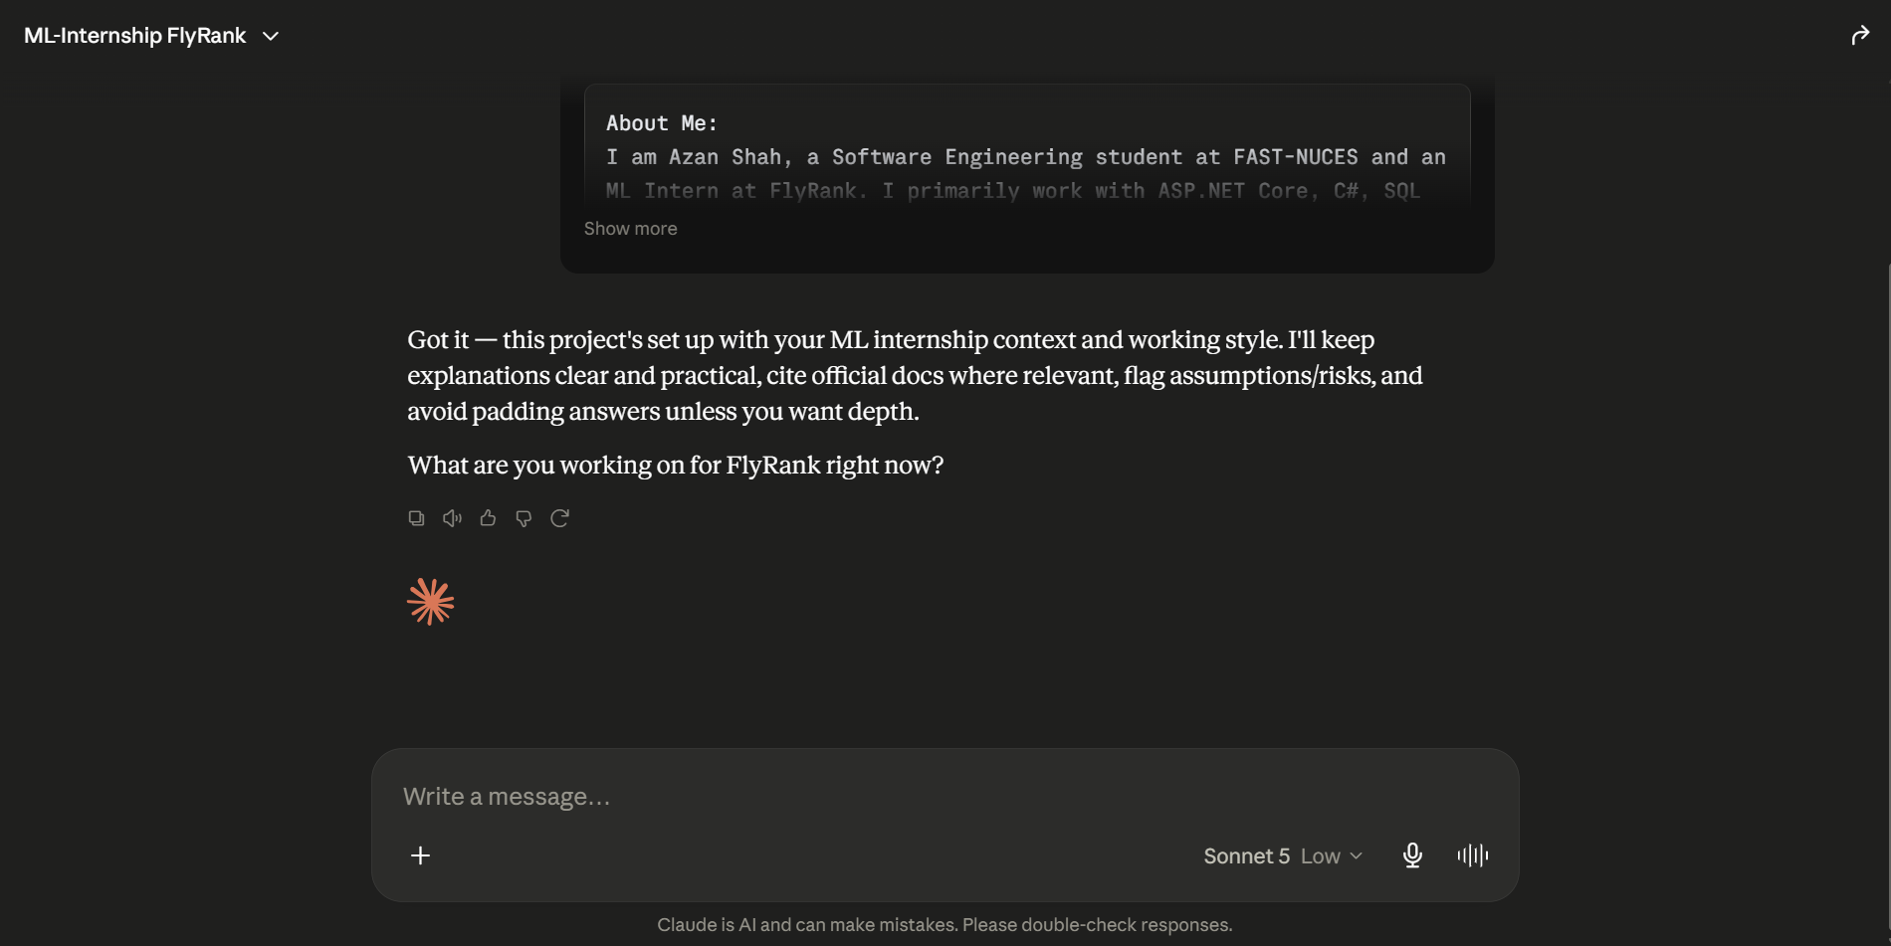
- Three Target Tasks:
1. API & Technical Research
Why I selected it: This is one of my most common internship tasks.
Success Definition
- Research completed within 45 minutes.
- Information gathered from at least 3 reliable sources, including official documentation whenever possible.
- Final summary includes integration approach, limitations, costs (if applicable), and implementation considerations.
- No significant factual errors after verification.
Debugging Software Applications (.NET & SQL)
Why I selected it: Debugging is a frequent part of both my internship and academic projects.
Success Definition
- Root cause identified within 30 minutes for typical issues.
- At least two possible solutions evaluated before selecting one.
- Final solution tested successfully without introducing regressions.
- Issue and solution documented for future reference.
3. Technical Documentation & Learning
Why I selected it: I regularly study new technologies and prepare documentation for projects.
Success Definition
- Produce concise notes within 20 minutes.
- Include key concepts, examples, and best practices.
- Organize content into clear sections for future reference.
- Be able to explain the topic without relying on the original documentation.

